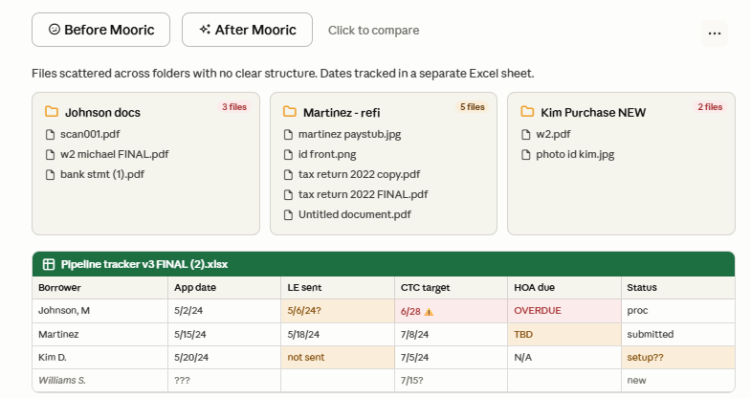
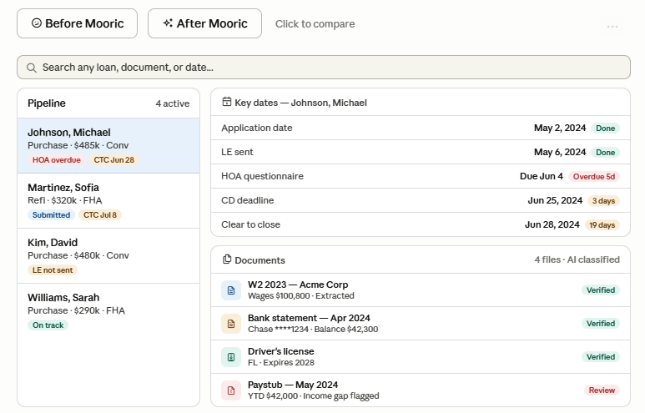

Website Content Brief — Interactive Before/After Demo
I want to add an interactive visual section to the homepage that shows the transformation from how LOs and processors work today versus how they work with Mooric ERP.
The concept
A side-by-side toggle that visitors can click between — "Before Mooric" and "After Mooric." No long explanations needed. The visual tells the story on its own.
Before Mooric — what it looks like today
Show the chaos that every LO and processor recognizes immediately:
- File folders with no consistent naming — "scan001.pdf," "w2 michael FINAL.pdf," "bank stmt (1).pdf," "Untitled document.pdf"
- Multiple versions of the same file with names like "FINAL," "FINAL v2," "copy"
- A messy Excel spreadsheet with columns for every important date — LE sent, CTC target, HOA deadline, appraisal due — with cells that say things like "TBD," "not sent," "??," or are just left blank
- No clear way to know what is missing, what is overdue, or where anything is
This should feel immediately familiar to anyone who has worked in mortgage. The goal is for them to look at it and think "that is exactly what my desktop looks like."
After Mooric — what it looks like with the platform
Show the same information, completely organized:
- Every loan in a clean pipeline list with status tags showing what needs attention right now — overdue items in red, upcoming deadlines in amber, on-track items in green
- Every document automatically classified and labeled — W2, bank statement, paystub, ID — with key data already extracted and verified
- All important dates for each loan visible in one place, color-coded by urgency, no Excel sheet needed
- A search bar at the top so the LO can find anything instantly
How it should work on the page
Two buttons — "Before Mooric" and "After Mooric" — that the visitor can toggle between. When they switch, the visual changes to show the contrast. Keep it simple and fast. The interaction itself is the message.
Placement
This should sit near the top of the homepage, right after the headline and the main value proposition. It is the first thing that makes a visitor say "yes, that is my problem" and "yes, that is what I need."

The core idea is that no LO needs to be convinced they have a problem. They already know. This section just needs to make them feel seen — and then show them what the solution looks like.

